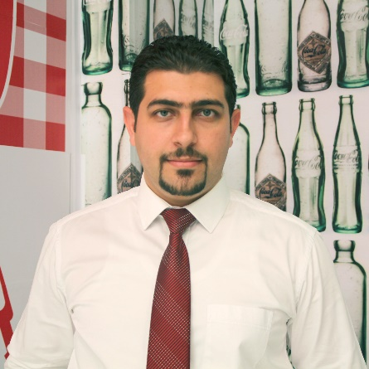

**Curriculum Vitae**

* **Name**: Mohammed Sami
* **Date of Birth:** 1985
* **Address:** Baghdad – AL Yarmouk
* **Graduation Date:** 2006/2007
* **Martial State:** Married
* **Tel**: 009647717770900
* **Email**: muhammadsami29@gmail.com
* **Academic certificate**
* BSC in English language / university of Baghdad / college of languages
* **Other business certificates**

1. Leadership and coaching skills
2. TOT
3. Collaboration for Value in Emerging Markets
4. CTCDP (Commercial Trainer Capability Development Program) - Coca- Cola Icecek , phase I , II , III 2014 , 2015 , 2017
5. Manager on Board
6. Business Target Setting

* **Previous positions:**
* Customer care agent \ Call center – Asia cell Telecom (+2 Years’ experience).
* Team Leader \ Call center - Asia cell Telecom (3 Years’ experience).
* Office Manager \ General Trading Company - (Nokan Group). 2 Years
* Commercial Trainer (Sales, Merchandising, Customer Service) Coca Cola Icecek.
* Sales & Merchandizing Training Supervisor Coca Cola Icecek .
* Area sales Manager @ Coca Cola Icecek . Current position
* **Experiences & qualifications**
* **Customer care Team Leader**
* my main duties and responsibilities was:  
  - Manage customer care agents team consist of 12 members.

- insure all their work needs are addressed.

- monitor their received calls, level of cooperation with customers.

- insure all answers are aligned with company vision, mission, polices & procedures.

- coordinate shift attendance, team leaves.

- insure all equipment inside the hall are work and report any maintenance needs.

- make monthly evaluation, weekly meetings to focus on weak points need to be addresses during the month and motivate, challenge team again.

- coach the team

* **Commercial Training Supervisor**

As a commercial training supervisor, I can brief my responsibilities:

* **Capability development:**
* Train and develop sales team commercial capability in terms of check the unseen opportunities in the market , handle customer objections , follow the a typical sales process to insure best sales comes from each outlets
* **Training environment.**
* Create a vital and encouraging training environment that make our sales team reveal more solutions , options , and make them get advantage from training day so we can start to see behavioral improvement all over the team
* annual training plan.
* Pre & Post test.
* **Train distributors staff.**
* Train distributor staff on make perfect delivery , customer service process so we can retain the brand more and extend our goal from selling only to sell & serve
* **Coaching ( in office , at field )**
* Coach the sales supervisor regard how to act in term of dealing with sales team , warehouse owner , workers , how to explore more options to see from different prospective one situation so we can reduce the turnover to the minimum level so we can keep out talents and improve the more
* Redirected , constructive Feedback
* **On Job Training**
* OJT in terms of selling process, market executions , dealing with customer complaints , see and discover the opportunities in the market
* **Soft Skills, Leadership & Management Training experience**
* Experiences in leadership, soft skills , communication skills and managerial level

**Area Sales Manger**

**In this position my responsibility is to manage sales team , Warehouses in the territory to achieve the target set by top management and that would include**

* **Manage sales team supervisors 3 , sales representatives 28 seller**
* Manage sales team at warehouse, at field , with all related concerns from sales force effectiveness , set the KPI’s that bring us more professional sales numbers , bring more sales staff discipline , manage all HR related things like , interviewing & hiring sales team , check the salaries , leaves , compile with company policies and adhere to company values
* **Set monthly targets**
* Set the monthly sales targets for all supervisors, and sellers , lead the forecasting process so supply chain , production , procurement team work in alignment with our production plan and selling targets so we will not face OOS or over stock issue . in addition to that lead correction action for short & long terms
* **Set market execution**
* Check and implement all market executions for traditional trade, and have very well experience in KEY Account & on premise executions as well in. work closely with trade marketing team & marketing team to provide all POP materials, equipment’s and lead all the agreements for rent in the assigned area. putting brand visibility, availability , brand loyalty increasing in addition to the market share as priority in our work
* **Manage the daily sales process**
* Daily following up for sales target achievement, explore all underperformance sales figures and team members and address these issue on daily basis.
* **Manage daily warehouses products orders**
* Daily ordering process, FEFO , expired products , damaged products sorting , delivery efficiency , warehouse worker efficiency
* Manage all Distributor issues , request , compensation with related depts.
* Coach team and provide feedback
* Increase to customers and keep, maintained our relationship with existence one.
* Support, guide our team in terms of HR instructions.
* Support other dept. like marketing, supply chain

**Wholesalers**

* We are keep a good relationship with all our KEY customers all over the area
* We provide direct discounts, product protection (damaged , expire compensations )
* My work field is traditional trade now
* Have very good connections from Baghdad to Hilla , Dewanya , KUT , Karbala , Najaf , semawa , Nassriya , omara and Basra to provide sales team , leading sales operation , gaining KEY Customers according to company vision , mission and kind of sales support provided ( discounts , product damage compensations , rental , annual agreements , ext… )

The will , experience , energy , mood to success are all on